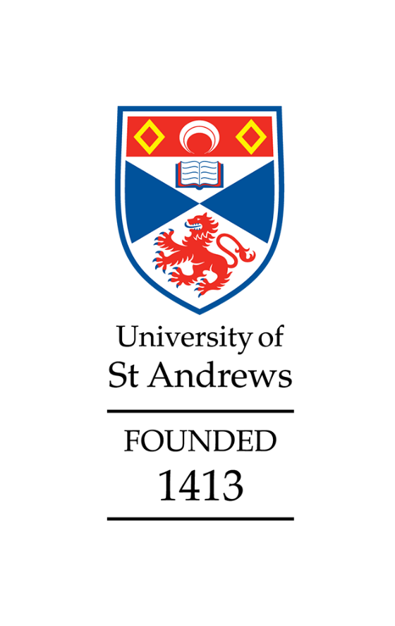

School of Mathematics and Statistics
Athena Swan
Silver application

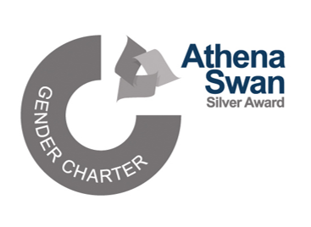
Awarded March 2024

Applicant information
Name of institution | University of St Andrews
Name of department | School of Mathematics and Statistics
Date of current application | 31 January 2024
Level of previous award | Bronze
Date of previous award | 18 May 2018
Contact email | Math-eq-div@st-andrews.ac.uk

Table of Contents
Applicant information 1
Section 1: An overview of the department and its approach to gender equality 2
1. Letter of endorsement from the head of the department 2
2. Description of the department and its context 5
3. Governance and recognition of equality, diversity, and inclusion work 7
4. Development, evaluation, and effectiveness of policies 8
5. Athena Swan self-assessment process 10
Section 2: An evaluation of the department’s progress and success 12
1. Evaluating progress against the previous action plan 12
2. Evaluating success against the department’s key priorities 14
Section 3: An assessment of the department’s gender equality context 17
1. Culture, inclusion and belonging 17
2. Key priorities for future action 20
Section 4: Future action plan 21
1. Action plan 21
Appendix 3: Glossary 28

Section 1: An overview of the department and its approach to gender equality

1. Letter of endorsement from the head of the department

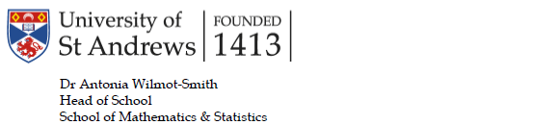

23 January 2024
Athena Swan Charter Advance HR Innovation Way York Science Park York, YO10 5BR

Dear Athena Swan Coordinator,
I started as Head of School (HoS) for Mathematics and Statistics in August 2023, and in the period between appointment and taking up the post joined the EDI committee’s meetings to familiarise myself with progress of the current application. Since August I have been involved in final preparation of the application, as a member of the writing group and by helping with the final self-assessment. Previously (2017-2022) I was Director of Teaching in the School and worked to implement the relevant parts of our previous action plan and advance equality particularly in our undergraduate population. I was pleased to see progress in embedding EDI in teaching was recognised in our latest University-led Review of Learning and Teaching. It is my privilege to be the first female HoS here, and EDI values form the central pillar of my commitment to the School.
Since renewing our Bronze award in 2018 the Director of EDI has joined the School Management Group, we have developed an EDI vision statement, and our EDI action plan is now a key component of our annual Operational Planning. The EDI committee has been restructured to improve representation. We have introduced new budget structures to provide School-wide EDI training, to further support the career ambitions of staff taking leave, and to develop our Education Focused staff. Additional support for promotion has been introduced, and the workload model restructured to better recognise the effort in major administrative roles and in teaching our now larger student cohorts.
Even with increased student numbers the School remains relatively small. The flat management structures and involvement of a wide range of staff in our administrative processes help support a collegial and agile environment that can respond rapidly to new ideas and feedback. Each of our committees has a member of the School’s EDI committee on it to further facilitate and embed EDI values in all our decision making. A large proportion of staff members and students have actively contributed to the SAT group and analysis of priorities over this period.
From staff and student feedback, and through analysing demographic data, we recognise that much more work is needed, as reflected in the four highlighted priorities. While our efforts have shown success in ‘the pipeline’, with female PGR students increasing from 24% (2018) to 41% (2022) and

research staff from 32% (2018) to 44% (2022), the total number of academic staff has increased only from 29% (2018) to 32% (2022). Additionally, and concerningly, while remaining above the HESA benchmark we have seen a 2.1% decline in the proportion of our female undergraduates across the period. Increasing the fraction of our female staff and undergraduates are two of our key priorities. For this application we considered the intersection of gender and disability as our focus on intersectional inequalities.
The Action Plan has my full support, and that of the School Management Group. I am committed to making sure the plan is delivered, and fostering a fairer School that supports the career advancement of students and staff of all identities.

Yours sincerely,


Antonia Wilmot-Smith

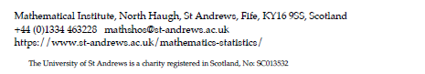

2. Description of the department and its context
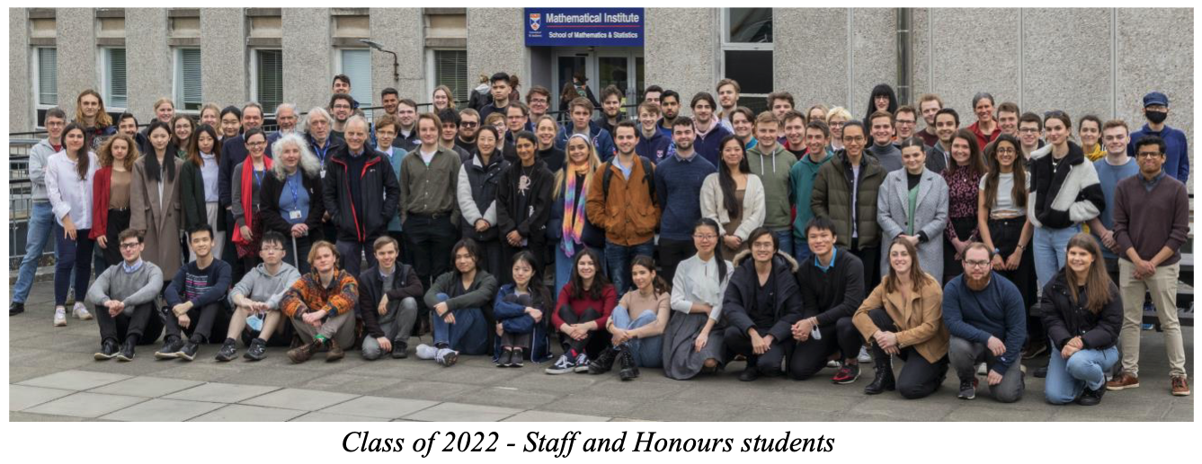
In this application we use the terms ‘woman’ and ‘female’ inclusively, to cover cis and trans women.
St Andrews has 10,468 students with 550 in Mathematics and Statistics (2022/23). Efforts to improve its track record on gender, social and ethnic diversity and inclusion resulted in Institutional Bronze awards in 2013 and 2018. The preceding and present Principals (Vice-Chancellors) have been women.
As noted in its Strategic Plan, the School prides itself on its diverse, friendly and welcoming atmosphere. Its teaching provision is routinely ranked among the top 10 in the UK (e.g. 9th in the 2023 NSS, 2nd in the 2024 Guardian University Guide). In the 2021 REF, the School ranked 19th. Student and staff numbers and gender proportions are given in Appendix 2 (we acknowledge a flaw in the data in that non-binary is not counted). In 2022/23, the School had 104 students (16% of population) disclosing a disability (87 undergraduate (UG), 11 taught postgraduate (PGT), 6 research postgraduate (PGR)). Fewer than 5 staff had a declared disability.
Women hold 36% senior roles, 26% academic roles, and 29% professorial positions. Two female professors from the School have been seconded to the Principal’s Office to take up senior leadership roles in the University, both as Vice Principals (VPs). In 2023 the School appointed its first woman Head of School, and the Directors of both Research Centres are women.

Senior roles 2023/24 (rotated on a 3–5-year basis)
Role | Gender
Head of School (HoS) | Female
Deputy Head of School (DHoS) | Male
Head of Pure Mathematics | Female
Head of Applied Mathematics | Male
Head of Statistics | Male & Male (role share)
Director of Research (DoR) | Male
Director of CREEM | Female & Female (role share)
Director of CIRCA | Female
Director of Equality, Diversity & Inclusion (DoEDI) | Male
Director of Impact and Innovation | Male
Director of Teaching (DoT) | Male
Director of Postgraduate Research (DoPGR) | Male
Director of Postgraduate Taught (DoPGT) | Male
School Manager | Female

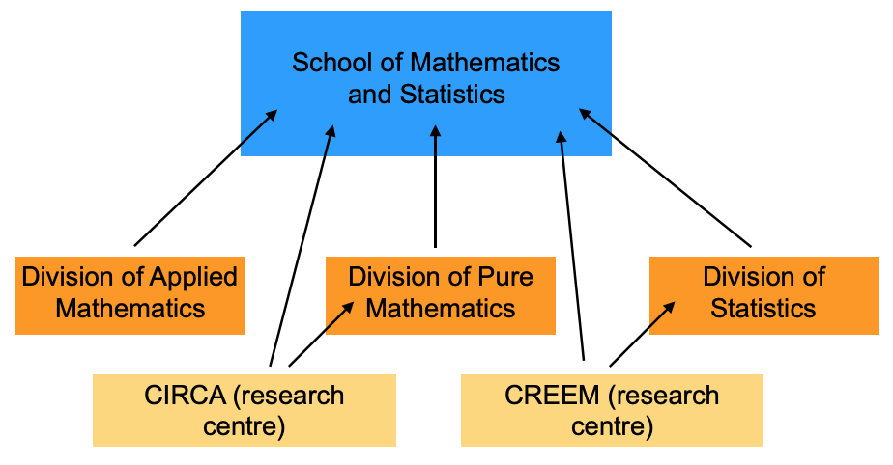
  - Figure 1: School Research Structure

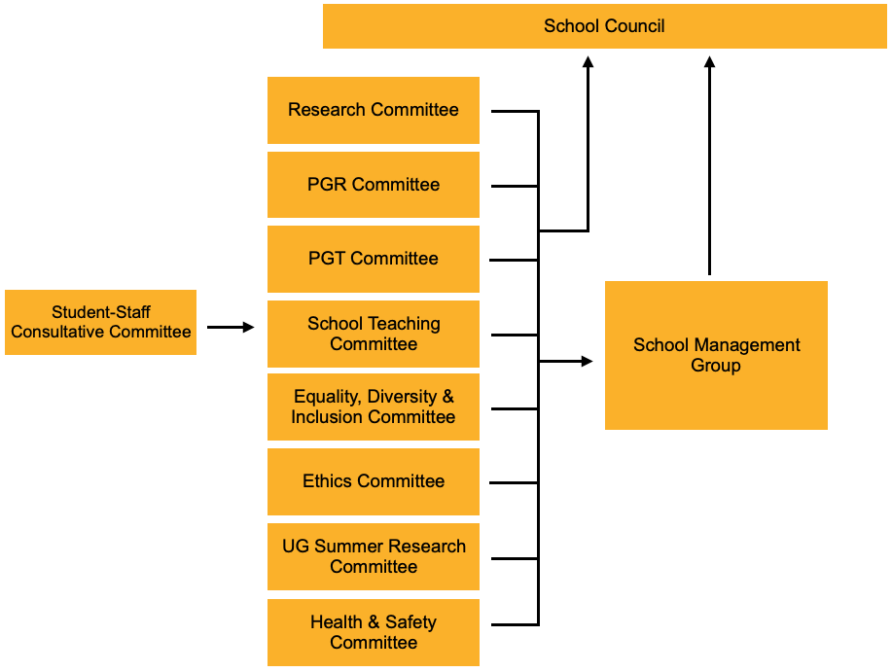
  - Figure 2: School Management Structure

The School has grown recently to 45 permanent academic staff (from 32 in 2014), including 5 female professors in 2022 (from 2 in 2014), 28 research staff and 9 research-active emeritus staff. Activity is structured around Research Groups in each of its Divisions (Figure 1). It also has a commitment to History of Mathematics and hosts the frequently and internationally accessed MacTutor History of Mathematics website which holds biographies of mathematicians from over 90 countries, including for over 300 women. The School is a founding partner of four interdisciplinary research centres joint with other Schools across the University. Two are led by the School: Centre for Research into Ecological and Environmental Modelling (CREEM), Centre for Interdisciplinary Research in Computational Algebra (CIRCA). Staff and research students have a primary research group affiliation, but many are members of more than one group, reflecting a culture of intradisciplinary activity.
Representation on all School Committees, including the EDI Committee, are reviewed annually by the Head of School and School Management Group (SMG). The review includes consideration of workloads and role, Division, and gender representation. The Director of EDI consults with the Head of School on this to ensure equitable workloads.
The School’s undergraduate population (550 FTE students in 2022/23), has increased (425 FTE in 2018/19), an expansion that was part of the 2020 Strategic Plan. The School offers an exceptional range of undergraduate single- and joint-honours degrees (64 UG programmes in 2023/24), creating an environment where each student can follow their own tailored course of study. Its provision spans a rich range of topics (e.g. 83 taught modules in 2023/24). The PGT population is smaller (51 in 2022/23, increased from 32 in 2018/19), with most programmes aimed at upskilling in statistical fields.
In the School’s main building, communal areas include two coffee/common rooms, where informal student and staff interactions are encouraged, and one general meeting room. CREEM is based in a separate building 10 minutes' walk away. The University plans a new building for the whole School by summer 2027.

3. Governance and recognition of equality, diversity, and inclusion work
EDI in the School is overseen by the Director of EDI (DoEDI) who chairs the EDI Committee.
The DoEDI is a senior role. In 2021 the DoEDI joined the School Management Group to increase EDI involvement in all School activities (AP3.6). In 2022 the DoEDI’s workload recognition was increased to 7.5 hours/week (previously 2 hours/week), a 20% role allocation like the DoPGR, DoPGT (20%) and DoR (25%). Committee members are given 0.5 hours/week, plus self-reported hours as part of Core Action Groups (CAGs). At least one member of the EDI committee sits on every other committee in the School.
Responsibilities of the DoEDI include: coordinating the School’s EDI operational and action plans, and applications for external accreditation; liaising with the Head of School; reporting EDI matters to School Management Group (monthly) and School Council (each semester); disseminating University EDI policy updates and delivering the University’s ‘Diverse St Andrews’ strategic ambitions at a School level; providing EDI advice and guidance to staff and students; working with the Wellbeing Officer to identify and deliver initiatives to enhance the School’s environment. The DoEDI is supported by central University EDI staff including a Faculty Lead and Awards Adviser.
The DoEDI chairs the EDI committee, whose work is underpinned by the School’s EDI vision statement: “To ensure that the principles of fairness and opportunity are fully embedded in School operations and strategic development so that our School is an outstanding place to work, study and collaborate, where everyone feels supported and valued, and where bias, bullying, discrimination, and harassment are not tolerated.” Aims of the committee include: embedding transparency and fairness in School practices; identifying concerns through review of surveys and data supplied by HR; developing, implementing, and monitoring departmental operational and action plans, including submissions for Athena Swan; sharing best practice with others to maximise impact; celebrating and promoting the School’s successes, particularly for under-represented groups. The EDI Committee has an annual budget of £1500 for travel to conferences, inviting seminar speakers, running training events such as Active Bystander, and creating posters.
All Divisions and job role types are represented on the EDI Committee, with membership sought through open and individual invitations. Previously, membership was limited to permanent staff. From 2020, a contract Research Fellow was added. Membership was further reviewed in 2022 following consultation with the University EDI HR Team, and five rotating student representatives were added, aiming to ensure that all voices are heard and valued.
The EDI committee is supported in developing Athena Swan action plans by Core Action Groups (CAGs) (see Section 1.5). There had been a concern about not having previously included students in this process; this was addressed by including UG, PGR and PGT Student Reps, the Disability and Academic Support Student Rep and the School President on the CAGs.
A dedicated EDI section of the School’s website publishes the vision, EDI committee aims and members.
Name  (academic year 2022/23 and 2023/24) | Position | Core Action Group | Athena Swan authorship role
Professor David Dritschel | Director of EDI | 4 | Lead author
Professor Mark Chaplain/Dr Antonia Wilmot-Smith | Head of School | 1/not applicable | No/Lead author
Dr Thomas Coleman | Lecturer and Student Wellbeing Officer | 2 | Lead author
Professor Isobel Falconer | Professor | 3 | Contributor
Dr Nicolò Margaritella | Lecturer | 4 | Contributor
Dr Eiren Jacobson | Research Fellow | 3 | Contributor
Mrs Fiona MacFarlane | Senior Research Administrator | 1 | Contributor
Dr Michael Papathomas | Senior Lecturer | not applicable | No
Ms Rachel Smith | School Manager/Staff Wellbeing Officer | 4 | Lead author
Zoë Gemmell/Krish Chaudhary | School President | not applicable | Contributor
Mukulita Chakravarty/Shanelle Advani | UG Student Rep | not applicable | No
Jiayi Liu/Varvara Konovalova | Disability and Academic Support Student Rep | not applicable | No
Lana Owen/Fabian Despinoy & Robert Young (role sharing) | PGT Student Rep | not applicable | Contributor/No
Kate Mowbray | PGR Student Rep | not applicable | Contributor

Core Action Groups: 1 (UG gender split), 2 (New building), 3 (Accessibility of information), 4 (Staff gender split)
In addition (1: Jack Reid, Ashley Clayton, 2: Aidan Naughton (former Director of EDI), Maria Tsalakou (PGR rep), 3: Ewan Gilligan (PGT rep), 4: Chris Sutherland, Ewan Philip (SP))

4. Development, evaluation, and effectiveness of policies
Policies are developed, evaluated, and revised across the School:
- by key role holders and their committees when a new or changed University policy is to be implemented, or when a policy-related issue is presented;
- by the School Manager as Professional Services lead through a process of working systematically to identify gaps in School policies. They then work with key role holders and committees on development.
New and revised School policies state the approval date and date for review, and dates are tracked by the School Manager to ensure adherence.
Key stakeholders are consulted during policy development/review. Policies are approved by the relevant committees and then disseminated. The SMG must approve policies involving significant change.
Consultation with students include:
- Exit interviews with final year undergraduates to evaluate and amend policy, e.g.: 2019 interviews led to implementation of a subject-specific advisor system; 2021 interviews asked, “Would you want to see any of the changes in teaching and assessment that were introduced due to Covid stay in the longer term?” and responses helped inform future assessment patterns.
- Discussion at Student-Staff Consultative Committee (SSCC) on teaching and student wellbeing-related policies, e.g. in 2022/23 discussion led to revision of School policy for releasing past exam papers and model solutions. In 2019/20 discussion of proposed changes to the semester date structure was fed back to the University.
- School and Student surveys of the student body, e.g. March 2020 student surveys of COVID-19 impact were fed to the Proctor and had a role in decision of no-detriment institutional policies that were implemented.
Consultation with staff include:
- Discussion of topical matters at a monthly ‘Lunch and Chat’ for staff and PGR.
- Single-topic teaching forums are held regularly, led by the DoT, e.g. a 2019 forum led to changes in the MMath Masters programme requirements.
- Dedicated School-wide in-person and email consultation for key policy changes, e.g. 2023 consultation on the School’s current workload model.
- The Director of EDI has opportunities to comment on institutional policy as a member of the University’s EDI Directors’ Network chaired by the Vice-Principal (People and Diversity).
The relatively flat structure of the University allows for effective communication (e. g. a staff meeting with the Vice-Principal Education on a proposed change of University calendar retained 11 teaching weeks in semester 2).
Examples of new or substantially changed School policies and guidance documents approved since 2021:
- Publication of an updated Workload Model in September 2023, following School-wide consultation, with significant changes to time allocated for teaching (motivated particularly by changed assessment structures and increased student numbers).
- Templates created for recruitment adverts and further particulars (AP5.1(c,d)). The templates make EDI commitment clear, state part-time and flexible working will be considered, and detail representation gaps where applicants are particularly welcome (2022). For academic staff, adverts highlight that applications from women are particularly welcome.
- Planning Family Leave policy including a checklist for staff and line managers. Also contains links to useful and further information – approved by EDI committee (2022). Central adoption of the family leave checklist was proposed by the Science and Medicine EDI Directors group and the University has subsequently adopted it (September 2023).
- The School introduced a personal annual travel/training/development budget of £500 for Education Focused staff in 2020/21. The fund is run by the DoT.

“The School has been extremely supportive and responsive with regards to my parental leave. They took care of finding replacements to temporarily take over my responsibilities and I was offered financial research support to allow my PDRA to continue collaborations in my absence” - Lecturer in Mathematics, 2023

Policies are communicated by email, the School Handbook, the School website and via a new online ‘All Staff’ Teams site, coordinated by the School Manager. The Teams site contains links to University policies, School-specific policies, and other pertinent information. New staff are added during their first week, and the Handbook is introduced both at induction and by email.
The Core Action Group for Accessibility of Information is making recommendations to the School EDI Committee to improve the School EDI webpage, linking to relevant policy or guidance information (FAP3.2).
All University policies are subject to an EDI review or a full equality impact assessment. Consultation includes staff diversity networks (such as the Staff Black, Asian and Minority Ethnic Network, Disabled Staff Network, Parent and Carers Network, LGBTQI+ Employees’ Network). Drafts of EDI-impacting policies are circulated to all 19 School DoEDIs for comment.

5. Athena Swan self-assessment process
All staff members on EDI Committee contributed to the drafting of the application. Those taking a lead role: Dr Aidan Naughton, former Director of EDI and Senior Lecturer; Professor David Dritschel, current Director of EDI; Professor Mark Chaplain/Dr Antonia Wilmot-Smith, Head of School until/from August 2023; Dr Michael Papathomas, former Director of EDI and Senior Lecturer; Professor Duncan Mackay; Dr Tom Coleman, Lecturer and Student Wellbeing Officer; Rachel Smith, School Manager; Kathryn Herschell, Equality and Diversity Awards Adviser.
The EDI Committee maintains responsibility for the 2018 Action Plan. Short-life working groups are formed for specific actions. EDI is a fixed item at both School Management Group and Staff Council, providing an opportunity for staff to input ideas/concerns. The EDI committee also acted as the self-assessment team for this application.
Regular School and University surveys provide quantitative and qualitative data on experience and opinion.
Following a School-wide workshop to identify EDI priorities and analysis of the 2020 School survey results (data analysis was conducted by a sub-group of the full EDI committee, reporting back to the Director of EDI), the EDI Committee decided upon the following key priorities:
- Undergraduate gender split
- Accessibility in the new building
- Accessibility of information
- Staff gender split

A Core Action Group (CAG) was created for each, with membership sought via an all-School email. EDI Committee members assigned themselves to a CAG, and each CAG developed a section of the Future Action Plan, emphasising addressing intersectional inequalities.
The School of Biology at the University has a gold Athena Swan award and is recognised as an innovative leader. Over the course of the Athena Swan period, there has been productive two-way dialogue between the Schools, to help Mathematics and Statistics assimilate best practice.

Timeline of application process:
2018: School received AS Bronze award; feedback wholly positive, School resolved to continue positive actions.
2019: EDI committee meets quarterly, plans, and progresses actions.
10/2019: School Manager post established (made ex-officio member of EDI Committee).
12/2019: Student Wellbeing Officer role established (made ex-officio member of EDI Committee).
06/2020: Review of 2018 action plan (initially set for March but postponed due to COVID-19). Decision to apply for Silver award. Validity of School’s Bronze award extended to 2023 as part of the transformed charter. 1st observation point for action evaluation.
11/2020: School EDI survey run (41 staff respondents, 16M:11W, 14 aggregated/other).
06/2021: Three-person working group set up to further review 2018 Action Plan. School-wide workshop run. 2nd observation point.
09/2021: DoEDI joined SMG. Staff Wellbeing Officer post established (made ex-officio member of EDI Committee). EDI committee became the SAT.
11/2021: University staff survey run.
12/2021: EDI committee decide on ‘core actions’ for future Action Plan; CAGs established.
06/2022: CAGs report to EDI Committee; core actions decided.
12/2022: EDI committee invited to contribute to initial draft.
08/2023: With text and key ideas contributed by the wider EDI committee, the lead author team was established to bring ideas together in narrative form.
09/2023: School EDI survey run (51 staff respondents, 27M:19W, 5 aggregated/other).
10/2023: Future Action Plan and RAG rated 2018 Action Plan drafted, both sent to SMG for approval. Data from School EDI survey analysed by subset of EDI committee. 3rd observation point.
11/2023: Future Action Plan, RAG-rated 2018 Action Plan finalised. EDI committee and external review of application draft.
01/2024: Final revisions based on review feedback. HoS communicated document to SMG and signed off application.

Future gender equality work
For the promotion of equality throughout the School, the Committee will:
- meet 4-5 times/year;
- review membership annually, including with an open call for expressions of interest in joining;
- further enhance our procedures for monitoring progress, including reporting action status, and preparing an EDI survey in annual operational planning cycles, to ensure the continued progression of future Athena Swan applications;
- disseminate information to staff and students, and;
- place further resources online to ensure our work is visible to all.

Section 2: An evaluation of the department’s progress and success

1. Evaluating progress against the previous action plan
The following RAG-rated table gives the most recent iteration of the 2018-2023 Action Plan associated with our previous Bronze award
[REMOVED FOR WEB PUBLICATION]

Actions arising from the 2018 Athena Swan award were communicated and overseen by the Director of EDI (DoEDI). A working group to monitor progress was established and in 2020, the DoEDI worked with the Committee to establish which actions should be taken forward through CAGs. Progress was evaluated periodically by a group within the EDI committee (DoEDI, HoS, School Manager, Tom Coleman, Michael Papathomas). The aim was to review progress annually, but additional logs were taken at times of rotation of the DoEDI role. In addition, in 2022 the University’s Operational Planning round changed to include EDI targets and monitoring in its annual submission. The School uses the Athena Swan table for this process, giving the HoS, SMG, and the Principal’s Office an additional opportunity for annual scrutiny. Our previous action plan covered 4 distinct areas, taking 24 objectives with 57 associated actions. The final RAG rating shows 6 (11%) red, 9 (16%) amber and 42 (74%) green actions, combining to 2 (8%) red, 8 (33%) amber and 14 (58%) green objectives.
We are proud of having a high proportion of green rated actions. Highlights are:
- A much more effective EDI structure: DoEDI sits on the SMG, regular meetings of CAGs and the EDI committee, EDI as an integral part of annual Operational Planning (AP3.3, AP3.4, AP3.6).
- EDI initiatives being central to new student schemes: a student Wellbeing Officer, local student mentoring and peer assisted learning, information in induction talks and module handbooks (AP4.1(a), AP4.4(d,f,g), AP4.7(d,g)).
- A closing of the awarding gap for our undergraduate students, as linked to the above (AP4.4(a,b,d,f,g)).
- The fraction of female PGT and PGR students rising to be well above the national averages (AP4.7).
- No single-sex shortlists for academic posts and an increased number of female staff in senior leadership roles (AP5.1(a,b,c,d,f,g), AP5.2(b,c,e)).
Changing higher education priorities, a realisation that the School did not have influence over some factors, and the COVID-19 pandemic all presented barriers to partial or full completion of some agreed actions.
The red-rated statuses of the action plan arise through a variety of reasons, which we categorise as follows:
- In 2018 some actions were thought to be achievable but, following further investigation and analysis, were found to be unachievable and were removed (AP5.1(e), AP5.3(b), AP7.1).
- The pandemic prevented some items being achieved within the time-period (AP3.5, AP4.1(b), AP4.2, AP4.3, AP5.2(c,e), AP5.3(a), AP5.4(c,e), AP5.4(f)).
- AP4.8 was determined to be outside the scope and remit of the School.
- Remaining items were affected by a high turnover of the role holder in the position of responsibility (AP4.4(c), AP5.2(d), AP5.3(a)).
Rationale for items ending as amber-rated can be categorised as follows:
- Some actions remain in progress. We intend to progress them, but they have been delayed due to the pandemic or other factors (AP4.4(e), AP4.8, AP5.2(a), AP5.2(g), AP5.3(a), AP5.8).
- In the early stages of the 2018-2023 cycle progress on the action plan was hindered by some key role holders not being aware of action plan points that had been assigned to them. The restructuring of Professional Services in the School and appointment of a School Manager (October 2019) helped in constructing a more systematic process around the action plan, with momentum on actions increasing from 2020, including through the DoEDI joining the SMG in 2021.
Effective communication strategies are the main point to learn from on the previous action plan. For the 2023 action plan, key role holders have been consulted on proposals and sent a list of agreements. The greater integration of the action plan to the School’s Operational Planning cycle means it has a continued high visibility in the School.

2. Evaluating success against the department’s key priorities
Two key achievements are closing the undergraduate degree awarding gap by gender and increasing the proportion of female PGR students. These were previously identified priorities and are discussed in more detail below. Additional important achievements in the period include:
- A steady increase in the percentage of female entrants at PGT level, from 39% in 2018/19 to 53% in 2022/23. Alongside this (and in accord with our intersectional focus) there has been a notable increase in fraction of all entrant PGT students declaring a disability, from 14.1% in 2018/19 to 20.4% in 2022/23 (3 times the number of disabled applicants in 2022/23 compared with 2018/19).
- Consistent work to increase the number of women in leadership roles has had some success, as noted in Section 1.1. In 2021/22 and for the first time, four members of staff were supported to take part in the Advance HE Aurora programme (APP5.2(c)). A further two members of staff took part in 2022/23.
- The new 3-week Paternity leave is fully implemented. The School has also offered additional support to staff taking leave and has increased visibility of EDI policies with a dedicated website area. As an example, in 2023/24 a Lecturer taking Shared Parental Leave has additional support through funding for his post-doc to visit a collaborator, ensuring momentum on the project can continue while the leave occurs.
- In 2022 the School created a repository for sharing best practice of successful grant applications and held sessions to discuss best practice with early-career colleagues.
- Recruitment of Academic and Professional Services Staff is overseen by the School Manager to ensure recruitment panels are representatively diverse, and that panel members have completed the University Recruitment and Unconscious Bias training.
In the 2018 Athena Swan application, our self-assessment identified four challenges, forming corresponding groups of actions. These were:
- A notably smaller percentage of female UG students attaining a 1st degree classification (AP4.4).
- The proportion of female PGR students remains low (AP4.7).
- Further increase of the proportion of female staff across all grades (AP5.1, AP5.2, AP5.3).
- Address comments in Staff/PGR survey relating to interpersonal communications (AP5.5).
Here we focus on describing achievements against items (I) and (II). Specific objectives from the SAT team related to these items were stated as:
- We aim, by 2022, to observe a difference in 1st attainment between male and female students of 5%, compared to 17% in 2015/2016 and 11% in 2016/2017 (AP4.4).
- Commitment to increasing the numbers of female PGRs to become 5% above the national average (AP4.7).

Progress against commitment to close degree awarding gap by gender
Considerable progress has been made regarding the gap in first-class degree attainment. Although the gap has historically been large (25% in 2018/19) it has since become more even. Female students outperformed their male counterparts in 2020/21 by 13%, and achievement was within the 5% target range in 2021/22. The difference is monitored in detail by the DoT each year with summary collated data provided by the University. The DoT sends detailed information to all academic staff after each June graduation.
Extensive student-staff project work between 2019 and 2022 analysed anonymised data (at module and degree level) in the School and more widely the Faculty of Science. Female students were found to outperform males on the BSc degree (in contrast to the MMath Masters degree), while male students tended to perform more strongly than females in theoretical modules (APP4.4(a)). White students were found to outperform students of other ethnicities across the Faculty. Faculty-wide gaps related to disability were also observed. Intersectional issues were highlighted. There is evidence in the literature that female students respond better to coursework than final examinations, where male students respond better. The School has reviewed the number of coursework components within all Honours modules and has increased the fraction of coursework in many of them.
The DoT and School Teaching Committee worked together in 2017/18 to identify factors that might partly lie behind the gender awarding gap, with resultant initiatives starting in 2017/18. The award data of 2019/20 represents the first student cohort graduating having started their Honours programme in 2017/18, and this is the first year seen where the gap is notably lower.
The overarching themes identified were that all students should feel part of a student community in the School; that the community should extend across levels of study; barriers should not be perceived between students and staff, with open communication and dialogue between them; students should feel individually supported by the School.
Specific Actions:
A mentoring scheme was set up for UG, MSc and PhD students, the first in the University to target all levels of student. Students can indicate if they would like to be a mentor or mentee for a student of any gender. The scheme took its first students in 2018/19, and has been coordinated by a student mentoring coordinator, with welcome events at the start of each year. It was taken over by the University after 2020/21 and extended to all Schools in the University. The Centre for Educational Enhancement and Development issue reports on the scheme at the end of each cycle (APP4.4(f)).
Posters illustrating School and University mental health support provision were placed prominently throughout the building. Provision for mental health support was included in Orientation Week presentations for all UG students and highlighted in module handbooks. These efforts have contributed to increased resilience amongst students (APP4.4(d)).
Maths Base, a Peer Assisted Learning Support centre supervised by staff, was introduced in 2017/18. It seeks to increase student confidence, provide additional opportunities for academic support at sub-honours and teaching-related experience at honours, and promote dialogue between different year groups. Anecdotally (report from the scheme coordinator) female students are more likely to be regular attendees at Maths Base.
Regular Student-Staff Coffee and Cake events have run since 2017/18. In 2022/23 there were 3 per semester, with an emphasis on student interaction with lecturers and fellow students across all levels.
Student wellbeing is regarded as a central pillar of supporting students to achieve the best outcomes. The School introduced a Student Wellbeing Officer in 2019/20, a position that was subsequently rolled out across the University. In 2019 the School worked with Student Services to offer an in-house four-hour Mental Health Toolkit session, to help staff know how to handle difficult conversations with students and provide appropriate signposting (AP4.4(d,e)).

Progress against commitment to increase the fraction of female PGR students
There has been improvement in the percentage of female PGR students, increasing from 24% in 2018/19 to 41% in 2022/23. This meets the previously stated aim of the fraction of female PGRs being 5% above the national average. In the last benchmarking data available to us, our fraction was 10.6% above the national average.
The increase has been underpinned by a 113% increase of application numbers from female PGR students in the period, while applications from male PGR students increased by only 27%. The balance of entrants reflects the balance of applicants. (See Tables 11 in Appendix 2.)
Several initiatives follow action points in AP4.7 of the previous action plan:
- Awards of funding for undergraduate summer research projects were made to reflect the gender balance in the applications and in the undergraduate cohort. Applications were individually solicited from a gender-balanced group of top students in the relevant cohort, so that the gender balance in the applications was more likely to reflect that of the cohort. Records were kept on the gender balance of students that undertook summer research projects (APP4.7(a)). (Data: 2018/19 11M:5F, 2022/23 14M:10F.)
- The top 10 male and female students were contacted individually after each exam diet in their final two years of study to encourage them to apply for a PhD in St Andrews or elsewhere (APP4.7(b)).
- Honours project supervisors were asked to encourage talented students to apply for PhDs should it be of interest (APP4.7(c)).
- At one of the annual residential undergraduate reading parties a current PhD student gave a talk on her own experience of being a PGR (APP4.7(d)).
- Several case studies that include female student and staff stories and experiences were uploaded to our website for prospective PGR students (APP4.7(e)).
- The advertising of PhD opportunities was expanded, and the wording of adverts was altered to promote our commitment to EDI and encourage applications from female students (APP4.7(f)).
- The School required that all adverts for PhD opportunities include the same EDI statements, and the same advertised criteria for acceptance. As part of the student Mentoring Scheme, promising UG students were paired with PGR mentors (APP4.7(g)).
In addition:
- The School’s Postgraduate Research Committee developed a set of criteria for assessing PGR applications. Decisions about funding for applications have been made according to these criteria since 2021 and they are published on the School’s website. The goal has been to make admissions decisions more transparent and equitable. In ‘tie-breaker’ cases of equally-scored candidates, the committee takes EDI data into account, scoring in favour of candidates from under-represented groups.
- The School works with the Piscopia initiative (a UK-wide community encouraging women and non-binary students to pursue a PhD in Mathematics) to encourage female undergraduates to pursue a PhD. This has included working with the St Andrews University Mathematics Society (SUMS) to stream Piscopia’s nationwide seminar series, where women and non-binary researchers working in academia present on their area of research and detail their career path.
COVID-19:
During the summer of 2020, the Wellbeing Officer convened a gender- and age-balanced ‘community working group’ of students to discuss options to socialise virtually. Maths Base and Student-Staff Coffee and Cake continued during the pandemic, with online events in GatherTown. Initially organised by staff and later by students, an informal seminar series was conceived and ran throughout the academic year. An online scavenger hunt for entrant students was developed to help this cohort acquaint themselves with mathematics and statistics at St Andrews; this event has been further developed to run in person as well.
These initiatives were part of a School effort to help all students achieve the best possible outcomes, both in and out of the pandemic. The change in outcome data has coincided with COVID-19, which is also the period where assessment formats changed. This included the School moving to time limited (2h+55 minute ‘overhead’ time) open book online exams and introducing a minimum of 20% coursework in each module. While closed book exams are now the norm again, a component of coursework has been retained in most honours-level modules and assessment formats have significantly greater diversity than pre-pandemic.

Section 3: An assessment of the department’s gender equality context

1. Culture, inclusion and belonging
The School continually strives to embed inclusivity and gender equality into its culture in three principal ways: (a) the way it welcomes staff and students; (b) the ongoing support it provides; (c) by creating a culture where people feel valued, i.e. celebrating people and their successes. Some illustrative examples and analysis of each are:

(a) Welcoming staff and students
- Staff recruitment takes place online via Teams, including to maximise accessibility for people with caring responsibilities. For successful candidates a follow-up visit, funded by the University, is offered prior to offer acceptance. Flexible and hybrid working is advertised to candidates.
- A mentor is identified for each new staff member in advance of their first day. The current HoS has a discussion with new staff on any general preferences for the mentor and implements these. This year a new female lecturer chose to have a female mentor, while a (male) member of staff had particular needs that were met by supplementing a formal mentor with an informal dedicated contact close to his office.
- A workload reduction is implemented for all new academic staff (80% workload in year one; 90% in year two; early-career researchers may have a greater reduction).
- Staff and students entering the building first see a monitor showing the “mathematician of the day”, which aims to feature people from traditionally under-represented groups (see image below).
- A dedicated Disability Officer meets with incoming students who have declared a disability and ensures appropriate adjustments are communicated with relevant academic staff.

“My mentor was so helpful and was always able to make time to help me with any questions I had” – Student Mentoring Scheme Participant, 2019

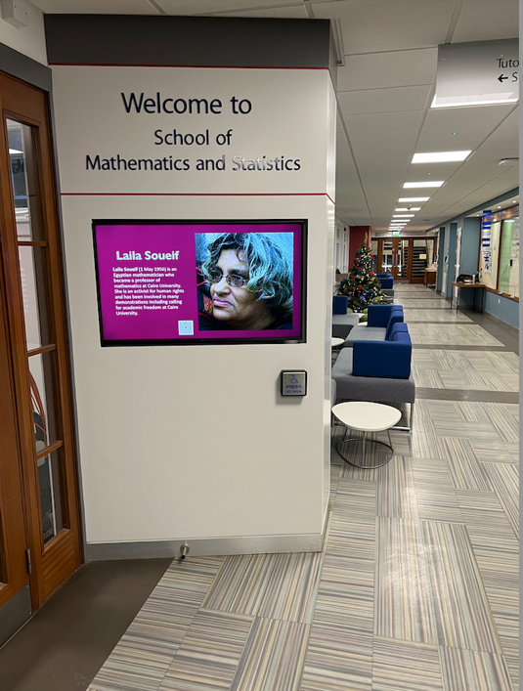
  - Rotating display in entrance corridor of the main building

(b) Ongoing Support
Staff:
- The hybrid working policy of the University is implemented to maximum extent by the School so that people can choose to work where they want to. This can be at the expense of School culture, e.g. reduced day-to-day interactions - the School is aware of the positive and negative impacts.
- Staff requests for flexible working (which are made more often by female staff members) are fully supported. Some previously full-time staff members currently work part-time, while another works compressed hours to accommodate caring duties. Special circumstances have a dedicated part of the promotions application and are considered in decisions. These arrangements are reflected in the 86% positive response rate (85%M:89%W) to Q5 in the 2023 survey. Periods of leave are supported and have been made more transparent (e.g. the family leave checklist, see Section 2.4). Staff returning from long-term leave (including for disability) have a teaching reduction for a comparable period. Additional budget has been offered to further support research activities. This culture is reflected in the 82% (81%M:89%W) positive response rate to the relevant question (Q2) in the survey.
- Activities are scheduled to be inclusive for staff members with caring responsibilities, with meetings held during core hours. A tight teaching timetable is used by the School (almost all lectures between 9am and 1pm) and requests not to teach before 10am for caring reasons are accommodated.
- The survey highlighted low positive responses to whether action has mitigated the gendered pandemic impacts (27%, 26%M:26%W). Work is needed to fully appreciate staff perspectives on this question and adapt future policy work accordingly (FAP4.7).
- For promotions, the HoS consults all professors in the School to collectively identify who might be able to apply for promotion and encourages individuals where appropriate. An internal gender-mixed panel offers feedback on draft applications, should the applicant wish. The related survey question (Q4,2023) has a 76% positive response (70%M:79%W).
- An active branch of the University’s Women in Science at St Andrews is supported in the School, including by workload model recognition for the lead, and provision of space for activities.
- The School has a dedicated Staff Wellbeing Officer who provides an additional layer of support. This has included ‘early intervention’ supportive referrals to Occupational Health.
- April 2021 interviews with recently arrived staff identified availability and transparency of information to be an issue for some female staff. Research has found availability of information can be a systematic barrier for marginalised groups. While efforts have already been made in this direction, the finding drives FAP3.1, FAP3.2 and FAP3.6. The intersection with disability is relevant here, as some policies and procedures (e.g. hybrid and flexible working, routes of self-referral to Occupational Health) are likely to be more relevant for disabled staff. In the survey some staff reported a lack of awareness of the School’s procedures for tackling bullying and harassment, feeding into FAP3.7.

“Being able to work flexibly and my line manager being understanding when I need to rearrange commitments at short notice has allowed me to continue to work full time as an academic in the School despite significant day to day impacts of my disability” – Senior Lecturer in Mathematics, 2023

Students:
- Maths Base (see Section 2.2), is designed to foster a sense of community, help sub-honours students learn from their peers, and help honours students learn how to communicate mathematics.
- While not all teaching spaces in the main building are fully accessible, all staff-student events (such as Maths Base) are now situated in accessible rooms; this has included mid-semester re-organisation to facilitate this.
- In 2022/23, the student School President (SP) and DoT organised mock exam time slots to help ease students' anxiety on returning to online closed-book exams, an action that particularly supported female students who were the majority (54%) of sign-ups (higher than the 37% female UG+PGT population).
- Where potentially negative behaviour is seen, the School aims to address it at an early stage. For example, during the pandemic a Discourse message board was initiated for students to discuss mathematical problems. In practice discussion was observed to be dominated by male students. Initial intervention by lecturers aimed to encourage participation by all, but with limited success, leading to closure. Module-level message boards are continued and have more balanced contributions.
- Our learning management system collates class lists, and each student can enter their pronouns to the system. This allows each staff member to see chosen pronouns against student name, which is particularly useful when taking small-group tutorials or other classes with more individual interaction.
- A student issue in the survey is the low proportion of students (16%, 13%M:23%W) who had heard of the Athena Swan Charter, highlighting the need to promote the charter and positive work in the School, including in start-of-year inductions for students (FAP3.8).
- The Student-Staff Consultative Committee was expanded in 2022/23 to include dedicated Disability and Academic Support and Equality, Diversity, and Inclusion representatives.

Regarding the inclusion of trans and non-binary people, work on a future action supporting belonging of our LGBT+ community began in Semester 1 of 2023/24, with a group of academics, research fellows and PGR students volunteering (with workload recognition or payment) to host Rainbow Office Hours during Semester 2. Students will be invited to attend these hours with an LGBT+ member of staff to discuss anything LGBT+ related. The School is also in discussion with Physics & Astronomy who have an LGBT+ champion on their EDI committee to learn best practice there. Work of the Piscopia initiative includes non-binary students and is supported by funds and facilities from the School.

(c) Culture around success
Evidence of a positive impact in celebrating success comes from a 78% (78%M:74%W) positive response rate to the survey question ‘My contributions are valued by the School’. A monthly newsletter highlighting student and staff achievements and recognitions, such as awards, honours, and successful PhD defences (as well as extra-curricular activities!), and staff gather at the end of each week for Friday Biscuits, celebrating achievements (and frustrations) of the week.
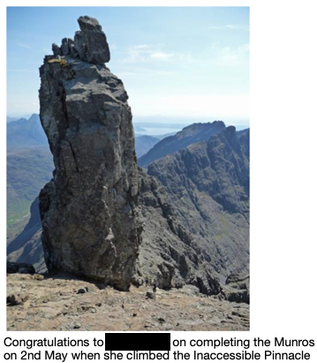

  - Example news items from the monthly newsletter.
“There is a strong PhD student community, who were very useful in giving support and advise on various aspects of PhD life” – Senior Female PhD Student

2. Key priorities for future action
Our self-assessment process (Section 1.5) identified four key priorities. Core Action Groups (CAGs) for each area were formed to assess the current situation, review procedures and propose actions to address any issues identified. The following summarises their findings:

1. Undergraduate student gender split
A gradual decline in the percentage of female undergraduates in recent years. While the School sits above the HESA comparison figure, we had a 3.4% decline in female students from 2018/19 to 2021/22, and latest figures show 35.8% female undergraduates (34.7% benchmark in 2021/22). We have not succeeded in identifying a key driver for this discrepancy.

2. Accessibility in the new Mathematics and Statistics building
A new building for the School is proposed to bring our two split sites into one community. Staff and students expressed concern that the diverse needs of occupants be integral to the design process, highlighting gendered (e.g. breastfeeding spaces, gender inclusive bathrooms, potentially different preferences of male and female staff regarding use of space since, for example, research shows female workers perceived they are observed in open-plan offices but male workers do not) and disability-related aspects (accessibility, working environment for neurodiverse people).

3. Accessibility of Information
This topic has two facets:
- Review and evaluate institution-wide and local policies, developing local policies where necessary, and ensure staff and PGR students can easily access the information through further development of the School website (Section 3.1).
- Routine provision of EDI data to the EDI committee, and hence the School overall, through committee logs and actions and their reports to School Council. Clear and timely data is useful for helping the School monitor the impact of its policies and for shaping future policies. As a School we feel priority (1) could have been identified earlier had data been systematically presented. As it was, the finding was first noticed in the 2021 teaching review when a collated trend set was obtained as part of required data.

4. Academic staff gender split
The percentage of female academic (Education & Research, Education Focused, Research Focused) in the School has remained almost static over the period, rising from 29% (2018) to 32% (2022). This is a period that has seen considerable expansion in staff numbers (66 staff in 2018, 81 in 2022), and although we are above the national benchmark (26% in 2021) our female staff fraction has risen even more slowly than the benchmark. In addition, our entry level positions have the lowest representation of women (20% in 2022) which will ultimately impact on the pipeline of progression to higher grades. Since COVID-19, in the 2021 and 2022 promotion rounds, only 17% of applications were from women compared to 33% in the 2018 and 2019 rounds.

Section 4: Future action plan

1. Action plan

1. Undergraduate student gender split
Ref. | Planned Action/Objective | Rationale | Key Outputs & Milestones | Responsibility: Oversight, implementation (if different) | Timeframe (Start/end date) | Success Criteria & Outcome
1.1 | Evaluate data (over period) on UG recruitment in order to assess the gender balance at UG level and to identify points of divergence | Determine whether current admissions policies are making an impact on the gender balance of applications, offers, acceptances and entrants | Annual presentation about data made by admissions team at an all-staff meeting | Admissions team | Annual throughout cycle | Report made every year
1.2(a) | Source a photographer to produce high-quality images representative of our student body for use in materials for prospective students | Images required to support 1.2(b) and 1.2(c) | All pages updated by start of 2025/26 academic year | EDI committee and Admissions team | Initial work in 2023/24, review after all school feedback in 2024/25 | Audit at start of 2025/26 shows improvement from 2023/24
1.2(b) | Conduct a yearly review of the School's Prospective Students webpage to ensure representation of both male and female students | Current pages sparse on images and are not always gender balanced and representative of our diverse community | All pages updated by start of 2025/26 academic year | EDI committee and Admissions team | Audit and initial work in 2023/24, review after all school feedback in 2024/25 | Audit at start of 2025/26 shows improvement from 2023/24
1.2(c) | Ensure images and quotes in prospectus are up to date and diverse | Current pages sparse on images and are not always gender balanced and representative of our diverse community | Prospectus updated for 2025/26 applicants | Admissions team | Prospectus development for 2025/26 brochure | Audit of 2025/26 prospectus shows improvement from 2023/24
1.3 | Update pictures in both the Maths Institute and the Observatory to ensure balanced representation of under represented groups | Many current images are of historical figures which tend to be white males | Images updated by September 2024 | EDI committee | Review starts in January 2024 | Images updated by September 2024
1.4 | Produce a video advertising the School to prospective undergraduates for display on the school website | Some prospective applicants prefer video images; videos can increase accessibility | Video placed on prospective student pages by September 2025 | UG recruitment lead | Start project in AY 2024/25. Material developed by end summer 2025 and online for 2026/27 applicants. | Video placed on prospective student pages by September 2025
1.5 | Keep a changelog of all public facing parts of the School webpage to ensure that progress is monitored | Accountability and transparency of activities of the School in EDI matters | Changelog exists | Professional Services Team | December 2023 onwards. | Changelog exists
1.6 | Ensure that at least one female staff member is present at every Visit Day | Previous Director of Admissions was female and led every Visit Day talk; since 2020 this has not been the case | At least one female staff member at every Visit Day | Director of Admissions | November 2023 onwards | At least one female staff member at every Visit Day

2. Accessibility in the new Mathematics and Statistics building
Ref. | Planned Action/Objective | Rationale | Key Outputs & Milestones | Responsibility: Oversight, implementation (if different) | Timeframe (Start/end date) | Success Criteria & Outcome
2.1 | At the next School Staff/PGR EDI survey, add a survey item similar to 'The School has made EDI a key priority in the design of the new building'. | To ensure items 2.2 onwards can be effectively tracked. | Survey for 2025 includes such a question | EDI chair | Summer 2025 | Question deployed in survey
2.2(a) | Ensure that a gender-balanced group from the EDI committee continue to attend building progression meetings with Estates to ensure accessibility is a priority in the project planning and dialogue with the School is effective | Make sure that EDI remains a central component of the design of the new building | Invitation lists for all such meetings include two members of the EDI team and EDI members report back to EDI and relevant committees | Head of School | Start March 2023 (initial stakeholder engagement  sessions), end expected August 2027 (projected completion date) | School-wide EDI surveys indicate that staff feel EDI concerns have been a central part of the design process
2.2(b) | Ensure that a gender-balanced group from the EDI committee continue to attend the 'Building User Experience' (or equivalent) stakeholder sessions and dialogue with the School is effective | Make sure that EDI remains a central component of the design of the new building | Invitation lists for all such meetings include two members of the EDI team and EDI members report back to EDI and relevant committees | Head of School | Start March 2023 (initial stakeholder engagement sessions), end expected August 2027 (projected completion date) | School-wide EDI surveys indicate that staff feel EDI concerns have been a central part of the design process
2.3(a) | Ensure the existence of a Wellbeing Room in the new building | A quiet, non-work environment space is required for activities such as breast-feeding and prayer | Wellbeing Room exists and is suitably furnished | Head of School | August 2027 | Wellbeing Room exists and is suitably furnished
2.3(b) | Ensure there is a refrigerator provided in the new building for the storage of breast milk and medications that require refrigeration | No fridge (or space for such a fridge) currently exists | Medical fridge is situated in the Wellbeing Room | Head of School | August 2027 | Medical fridge is situated in the Wellbeing Room
2.3(c) | Ensure that all relevant images in the new building ensure balanced representation of under-represented groups | To ensure the building feels a welcoming and inclusive space for all its users | Annual survey of images carried out (each summer) | EDI committee, EDI chair and Head of School | August 2027 and onwards | Balanced representation across spaces in the School
2.4(a) | Consult with staff and students on any outstanding accessibility needs when the new building opens | Make sure that EDI remains a central component in everyday use of the new building | Anonymised online 'suggestion box' within first year of building opening. | EDI chair | Within one year of new building opening | Any outstanding needs for accessibility acted upon.
2.4(b) | Institute an annual survey of members of the School of Mathematics & Statistics to ensure that the new building continues to evolve according to examples of best practice in accessibility | Make sure that EDI remains a central component in everyday use of the new building | Online survey | EDI chair/EDI committee | Within one year of new building opening | Survey exists, is completed within the year, and results disseminated to the School.

3. Accessibility of information
Ref. | Planned Action/Objective | Rationale | Key Outputs & Milestones | Responsibility: Oversight, implementation (if different) | Timeframe (Start/end date) | Success Criteria & Outcome
3.1 | Perform a full audit of the School website ensuring that all the information presented is accessible. | Audit had commenced, but has stalled. EDI Committee to continue to review and maintenance performed regularly | Robust process and communication flow between EDI committee, key role holders and admin teams with visible updates to website | HoS/School Manager | June 2024 onwards | Standard operating procedures and processes evident
3.2(a) | Investigate best practice, both internally and externally, in presenting EDI information on School websites | Audit had commenced, but has stalled. EDI Committee to continue to review and maintenance performed regularly | Written report to the EDI committee. | EDI chair/School co-ordinator | June 2024 onwards | Standard operating procedures and processes evident
3.2(b) | Identify gaps and strengths of the EDI information provided on School of Maths and Stats website when compared to other Schools/institutions | Some feedback in the School has indicated a lack of diverse images | Written report to the EDI committee | EDI chair/School co-ordinator | June 2024 onwards | Standard operating procedures and processes evident, feedback received is positive and no further gaps identified
3.2(c) | Update the dedicated EDI webpage for the School to ensure it fully reflects our EDI philosophies, policies and actions | Continue to consult and review appropriate content for the School webpage, actioning appropriate revisions and additions of content with regular review timeframes in place | Written report to the EDI committee | EDI chair/School co-ordinator | June 2024 onwards | Revised, up-to-date and appropriate content visibly
3.4(a) | Identify specific data that the EDI committee would like to receive each year from University planning | Currently only receive data for applications. More 'real-time' data will better shape future School EDI policies. | EDI committee meeting to decide on this specific data to receive every year; formal request made to University planning; delivery of data every year. | EDI chair/EDI committee | By June 2024 | Delivery of data each year from August 2024.
3.4(b) | Once yearly data is received from University planning, EDI Committee to report on this data every year. | Currently only receive data for applications. More 'real-time' data will better shape future School EDI policies. | Data received and analysed by EDI committee in first meeting of academic year; report by EDI chair to School council. | EDI chair/EDI committee | In time for October School Council meetings, every year | Reports by EDI chair contained in minutes of School Council.
3.5 | Increase completion rate of online Staff Diversity Training Module and the online Staff Unconscious Bias Training Module | Make aware that any interactions with prospective students and staff needs to adhere to EDI requirements | Issue reminders to complete twice a year. | School Manager | Annually (May) | 75% completion rate of both modules observed in timeframe
3.6 | Ensure that School Handbook is reviewed every year. | Make sure that policies, guidance are accessible and up-to date | All officers and directors asked for updates by end of each June, update completed by end of July | School co-ordinator | Annually (August publication) | Booklet update on School website and Teams area, and printed copy given to each new start
3.7(a) | Ensure that the University's Report and Support tool is well publicised to staff | Only 50% staff satisfaction in cultural survey about how bullying and harassment are addressed in the School | Written information sent to staff annually | Head of School | Annually (January) | Increased satisfaction in future cultural surveys
3.7(b) | Ensure that the University's Report and Support tool is well publicised to students | Only 64% staff satisfaction in cultural survey about how bullying and harassment are addressed in the School | Information disseminated to students at least annually via the Director of Teaching's annual induction talks | Director of Teaching | Annually (September) | Increased satisfaction in future cultural surveys
3.8 | Ensure that students are aware of the Athena Swan charter | 16% of students surveyed in September 2023 were aware of the Athena Swan charter | Information disseminated to students at least annually via the Director of Teaching's annual induction talks, as well as increased visibility of any awards (at both School locations and online) | Director of Teaching/School co ordinator | Annually (September) | Increased awareness in future cultural surveys

4. Staff gender split
Ref. | Planned Action/Objective | Rationale | Key Outputs & Milestones | Responsibility: Oversight, implementation (if different) | Timeframe (Start/end date) | Success Criteria & Outcome
4.1 | Highlight flexible working policies in adverts by ensuring up-to-date links to School/Institution pages | To encourage applications from a more diverse staff cohort, particularly considering St Andrews' geographic location (restricted availability of other jobs in the close vicinity) | Links to public-facing pages inserted in all future adverts. | School Manager | January 2024 onwards, to be reviewed in August every year | Links in all adverts.
4.2 | Investigate additional advertisement venues that specifically target women to increase the number of female applicants, and use appropriately identified venues | Aim to increase the number of women who apply to vacancies in the School | Identify possible suitable places to advertise; placement of adverts | School Management Group | December 2023 and annually | Searches completed. If relevant, adverts placed.
4.3 | Ensure job adverts do not contain excessive masculine wording. Where possible, gender balanced wording should be used instead | Aim to increase the number of women who apply to vacancies in the School. Current research indicates that this is an issue across multiple sectors (https://www.ncbi.nlm.nih.gov/pmc/articles/  PMC8905631/) | Analysis of current adverts based on latest recommendations | School Manager ; member of EDI committee | Summer 2024 | Analysis complete, and any recommendations implemented.
4.4(a) | The School will invite any successful candidate at remote interviews to visit the University post- offer, and cover any reasonable associated costs | Since every interview is currently online (as per University HR policy), candidates will not have a chance to visit where they will work prior to a long-term commitment of employment; by doing this, will promote a sense of community and inclusion | Implement for all future recruitment rounds. Uptake of offer. | Head of School, School Manager | January 2024 for initial contact; ongoing if successful | Contact made with HRBP; if successful, implementation of policy
4.4(b) | Offer to cover caring costs associated with interview | To give every candidate the best chance of success at interview, there needs to be provision in place for care of any dependants; this is a concern even with online interviews | Contact HRBP about this proposal to investigate feasibility and financial implications; if successful, implement as soon as is possible | Head of School, School Manager | January 2024 for initial contact; ongoing if successful | Contact made with HRBP; if successful, implementation of policy
4.4(c) | At every interview for any position, verbally mention that flexible and part-time working can be considered | This is a policy that needs to be made clear at every opportunity. In the case of post-doctoral researchers, we recognise that there may some constraints due to funding body regulations. | Ensure that up-to-date recruitment policies are disseminated to all members of interview panels. | School Manager, Head of School | Summer 2024 and ongoing | Email sent to interview panel for every vacancy detailing that this should be mentioned at interview; include in checklist from 4.5(d)
4.4(d) | For every interview, institute a School-specific 'checklist' to ensure that all standard procedures are followed during the interview | This not only underlines School commitment to best interview practice, but also increases accessibility of information prior to interview | Creation and institution of checklist, which will be shared with interview panels for every position | School Manager, Professional Services Team | Summer 2024 and ongoing | Create checklist, and use checklist at every interview
4.5 | Investigate the appetite for Maths&Stats specific peer-to-peer professional development discussion lunches | Similar initiatives exist in Schools from across the University; this will give colleagues in Maths&Stats the same localized opportunities as colleagues in other schools | Gauge response and act accordingly | EDI chair | Investigations over academic year 2023/24 | Decision on whether to progress initiative
4.6 | Encourage more staff to complete the Aurora training, by promoting this scheme every year | Previous action plan for having 2 staff members on the programme was successful, and scheme was found useful by staff who took part suggesting more widespread use would be helpful | Promotion across the School as the round is announced each year | EDI chair | Annually | Interest shown across the School and any feedback received in the School is positive
4.7 | Investigate reasons for low fraction of positive responses to Q6 of the September 2023 cultural survey | Cultural survey had 27% positive/61% neutral response to question 'The School has taken action to mitigate the adverse gendered impact of the COVID-19 pandemic on staff'; further information is needed to fully appreciate the responses | Collection of anonymized responses via online form; report produced from these responses | EDI chair | Start January 2024 | Written report to Head of School shared with School Management group by September 2024

Appendix 3: Glossary

AP | Action Plan
AS | Athena Swan
AY | Academic year
CAG | Core action group
CAPOD | Centre of Academic, Professional and Organisational Development, now split into CEED/OSDS
CEED | Centre for Educational Enhancement and Development
CIRCA | Centre for Interdisciplinary Research in Computational Algebra
CREEM | Centre for Research into Ecological and Environmental Modelling
DHoS | Deputy Head of School
DoEDI | Director of Equality, Diversity, and Inclusion
DoPGR | Director of Postgraduate Research
DoPGT | Director of Postgraduate Taught
DoT | Director of Teaching
ECU | Equality Challenge Unit, now part of Advance HE
EDI | Equality, Diversity, and Inclusion
FAP | Future action plan
FTE | Full-time equivalent
HEA | Higher Education Academy, now Advance HE
HEI | Higher Education Institute
HoDoMs | Heads of Departments of Mathematics
HoS | Head of School
HR | Human Resources
LERU | League of European Research Universities
LMS | London Mathematical Society
LTC | Learning and Teaching Committee
NSS | National Student Survey
ORTUS | Ortus Economics Research Ltd, private company
OSDS | Organisational and Staff Development Services
PG | Postgraduate
PGR | Postgraduate research (PhD degrees)
PGT | Postgraduate taught (MSc degrees)
PTO | Professional, Technical, and Operational Staff
RAG | Red-Amber-Green
REF | Research Excellence Framework
rUK | Rest of UK (outside of Scotland)
SAT | Self-assessment team
SDF | Student Discussion Forum
SIMD | Scottish Index of Multiple Deprivation
SM | School Manager
SMG | School Management Group
SOI | Scottish Oceans Institute
SP | School President
SSCC | Student-Staff Consultative Committee
STARIS | St Andrews Research Internship Scheme
STEMM | Science, Technology, Engineering, Mathematics, Medicine
STEP | Summer Teams Enterprise Project
SUMAC | Not an acronym, mentoring software company
SUMS | St Andrews University Mathematics Society
UCAS | University and Colleges Admissions Service
UG | Undergraduate
VP | Vice-Principal

